Missing Signals:

Numeric:

1. Missing Asthma – signals – more than 1 milion record of numbers, not null tens of thousand rows.

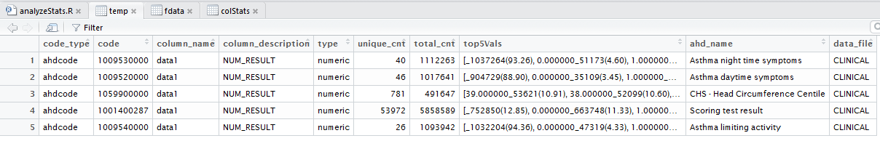

Also READ_CODE in CLINICAL has records of some family history diseases, allergies.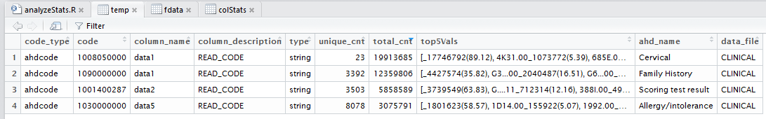

Also missing:

* CLINICAL - 1006100000 (Waist circumference) - WAIST(CM) in data1/ 750K items (most of them not nul)
* CLINICAL - 1009200000 (Epilepsy - Fit details) –
* CLINICAL – 1008050000 (Cervical) - ADEQUATE(Y/N) in data6 – almost – 20M records with values

Problems:

1. Height- is in meters, in maccabi it's in cm – fixed!